SIMATS ENGINEERING
ASSESSMENT TOOL 3

COURSE NAME: Database Management Systems COURSE CODE: CSA05

COURSE OUTCOME COVERED

CO4: Design database solutions incorporating file organization, indexing, and hashing techniques to optimize data storage and retrieval efficiency. (BL3, BL4)

Activity Tool : Comparative Analysis (Low) Assessment Tool Weightage: 10%

QUESTIONS
Q.N  o | Question | Bloom's Level
1 | Compare sequential file organization and heap file organization in terms of data insertion, deletion, and retrieval efficiency. | Bloom’s Level: 4 – Analyze
2 | Differentiate between clustered indexing and non-clustered indexing with suitable database examples. | Bloom’s Level: 4 – Analyze
3 | Compare primary indexing and secondary indexing based on storage requirements and search performance. | Bloom’s Level: 4 – Analyze
4 | Analyze the differences between static hashing and dynamic hashing in database systems. | Bloom’s Level: 4 – Analyze
5 | Compare B-Tree indexing and B+ Tree indexing for large-scale database applications. | Bloom’s Level: 4 – Analyze
6 | Differentiate linear hashing and extendible hashing in terms of bucket management and scalability. | Bloom’s Level: 4 – Analyze
7 | Compare dense indexing and sparse indexing with respect to memory usage and access speed. | Bloom’s Level: 4 – Analyze

8 | Analyze the advantages and limitations of indexed sequential file organization versus direct file organization. | Bloom’s Level: 4 – Analyze
9 | Compare single-level indexing and multi-level indexing for efficient database retrieval operations. | Bloom’s Level: 4 – Analyze
10 | Evaluate the performance of hashing techniques and indexing techniques for exact-match and range queries in databases. | Bloom’s Level: 5 – Evaluate

Code of Conduct:

I SUBASHREE.N-192521377 (Name / Reg No) certify that this submission is my original work and that I have adhered to the guidelines specified for this assessment. I understand that any violation of academic integrity rules will result in disciplinary action.

Signature of the student:
SUBASHREE.N

RUBRICS FOR CALCULATION:

Criteria | Weigh tage (%) | Level 4 (Exemplary) | Level 3 (Proficient) | Level 2 (Developing) | Level 1 (Beginning)
Scope of Items | 20% | Selects highly relevant items with clear scope and justification | Selects appropriate items with minor gaps | Selection is limited or partially relevant | Items are unclear or not relevant
Compari son Depth | 25% | Provides detailed and comprehensive comparison across multiple aspects | Provides adequate comparison with some depth | Limited comparison with few aspects | Very minimal or no comparison
Use of Evidenc e | 20% | Supports comparison with accurate data, examples, or  references | Uses some supporting evidence with minor gaps | Limited or weak supporting evidence | No supporting evidence provided
Critical Thinking | 20% | Demonstrates strong critical thinking with clear interpretation and reasoning | Shows reasonable interpretation with minor gaps | Basic interpretation  ; lacks depth | No meaningful interpretation
Clarity of Presenta tion | 15% | Well-organized, clear, and logically structured presentation | Generally clear with minor issues | Somewhat unclear or poorly structured | Disorganized and difficult to understand

Q1. Sequential File Organization vs Heap File Organization

Aspect | Sequential File Organization | Heap File Organization
Insertion | New records are usually inserted according to a specific order, so insertion can be slower. | Records can be inserted wherever free space is available, making insertion fast.
Deletion | Deleting a record may require maintaining the sequence of records. | Deletion is simple, although free spaces may be created.
Retrieval | Very efficient for sequential processing and ordered searches. | Efficient for scanning the complete file but slower for finding a particular record.
Searchin g | Can use the ordering to improve searching. | Usually requires a linear search if there is no index.
Best use | Suitable for reports and applications that process records in order. | Suitable for applications where records are frequently inserted.
Example | Student records arranged by Register Number. | Temporary transaction records stored without any particular order.

Analysis:
Sequential organization is better when records need to be accessed in a particular order. Heap organization is better when fast insertion is more important. Therefore, the choice depends on whether the application mainly performs ordered retrieval or frequent insertion.

Q2. Clustered Indexing vs Non-Clustered Indexing

Aspect | Clustered Indexing | Non-Clustered Indexing
Data arrangement | Determines the physical order of records. | Does not change the physical order of records.
Number | Usually only one clustered index per table. | Multiple non-clustered indexes can be created.
Range queries | Very efficient because related records are stored together. | Less efficient than clustered indexing for large range retrievals.
Storage | Index and data are closely related. | Requires additional index storage.
Example | Employee table clustered by Employee_ID. | Separate index on Employee_Name.

Main  advantage | Fast retrieval of groups or ranges  of records. | Provides fast searching using  different columns.

Example:
Suppose an employee table is physically arranged according to Employee_ID. A clustered index on Employee_ID allows nearby employee records to be accessed efficiently. A
non-clustered index on Employee_Name separately stores name entries and pointers to the actual records.

Analysis:
Clustered indexing is generally better for range-based retrieval, while non-clustered indexing provides flexibility when searching using different attributes.

Q3. Primary Indexing vs Secondary Indexing

Aspect | Primary Indexing | Secondary Indexing
Based on | Usually created using the primary key or ordering key. | Created on a non-ordering attribute.
Storage | Generally requires less index space, especially when sparse. | Often requires more storage because it may need more index entries.
Search  performance | Very good for primary-key searches. | Good for searches on non-primary attributes.
Duplicates | Primary key values are unique. | Secondary index may contain duplicate values.
Example | Index on Student_ID. | Index on Department or Student_Name.
Use | Finding records using their unique identifier. | Finding records using other frequently searched attributes.

Analysis:
Primary indexing is efficient when the application frequently searches using a unique key. Secondary indexing improves flexibility but may require additional storage. For example, searching for a student using Student_ID is naturally suited to primary indexing, while searching students by Department can benefit from secondary indexing.

Q4. Static Hashing vs Dynamic Hashing

Aspect | Static Hashing | Dynamic Hashing

Number of buckets | Fixed when the file is created. | Can increase or decrease as data changes.
Scalability | Limited for growing databases. | Highly scalable.
Overflow | Overflow buckets may be required when buckets become full. | Handles growth by splitting buckets.
Performance | Can decrease when many overflow records occur. | Maintains better performance as the database grows.
Complexity | Simple to implement. | More complex to implement.
Example | Fixed hash table for a small student database. | Extendible hashing used for a growing customer database.

Analysis:
Static hashing works well when the number of records is relatively stable. However, when a database grows continuously, dynamic hashing is more suitable because it adjusts the bucket structure. Thus, dynamic hashing provides better scalability, while static hashing is simpler.

Q5. B-Tree Indexing vs B+ Tree Indexing
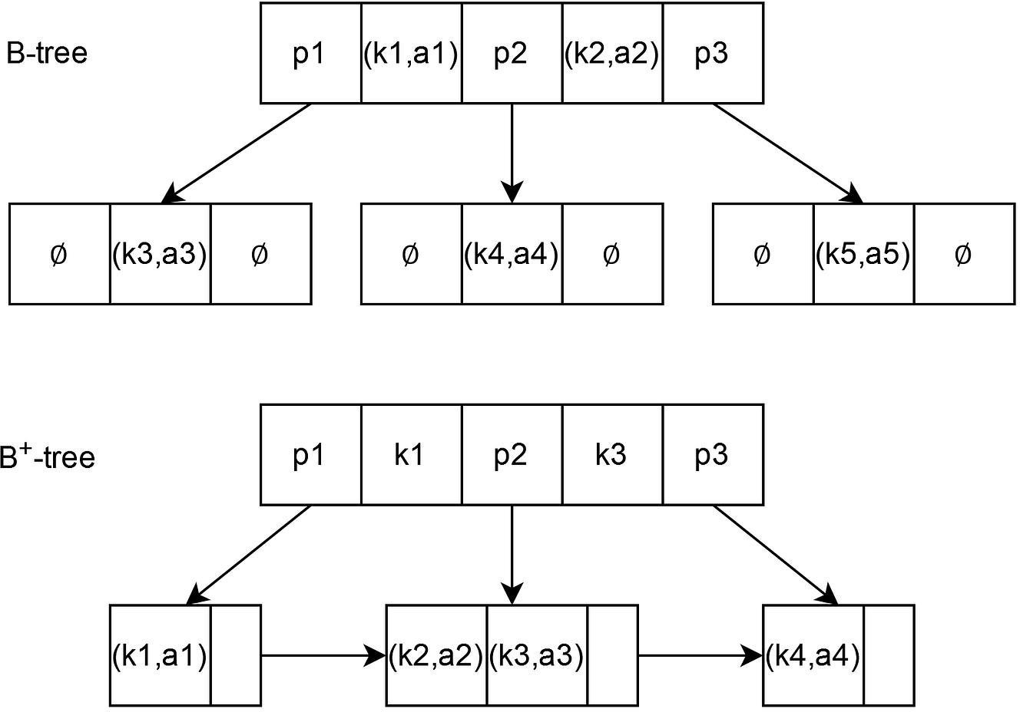

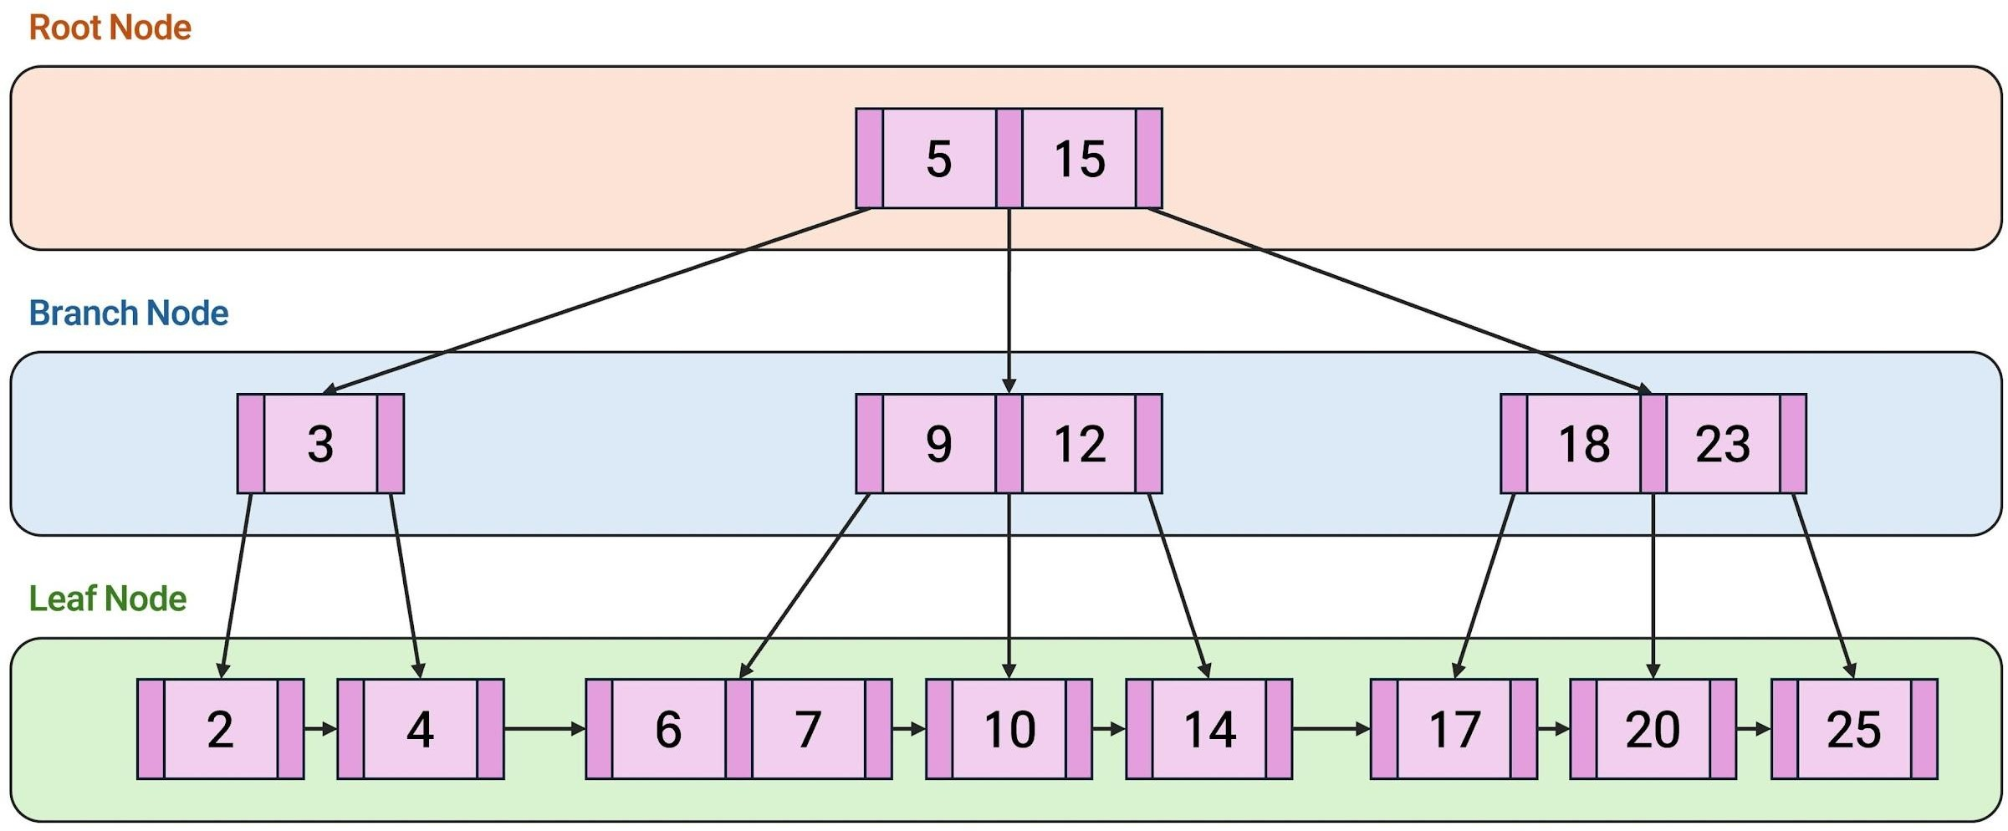

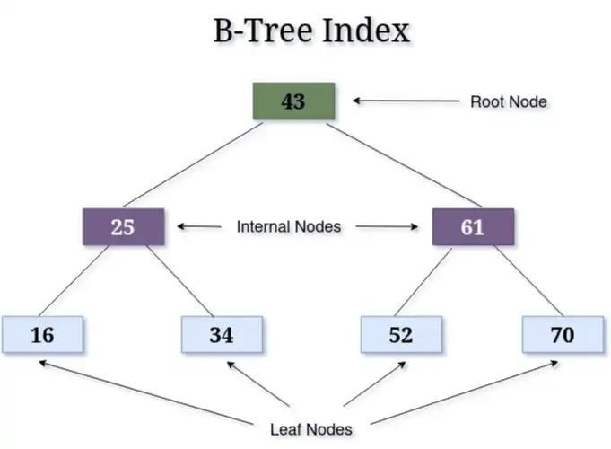

Aspect | B-Tree | B+ Tree
Data  storage | Data pointers/records can exist in internal and leaf nodes | Actual record pointers are stored mainly at leaf nodes.
Leaf nodes | Usually not necessarily linked. | Leaf nodes are linked sequentially.
Range queries | Less efficient compared with B+ Tree. | Very efficient because leaf nodes are linked.
Search | Good search performance. | Excellent search and range-query performance.
Fan-out | Lower compared with B+ Tree in many implementations. | Higher because internal nodes store only keys and child pointers.
Database use | General-purpose indexing. | Widely preferred in database systems.

Analysis:
B+ Trees are generally preferred for large-scale databases because their linked leaf nodes make range queries and sequential access faster. Their higher fan-out can also reduce the height of the tree, resulting in fewer disk accesses.

Q6. Linear Hashing vs Extendible Hashing

Aspect | Linear Hashing | Extendible Hashing

Bucket growth | Buckets are split gradually in a linear order. | Buckets are split based on hash prefixes.
Directory | Does not require a directory. | Uses a directory containing bucket pointers.
Scalability | Good for gradually growing files. | Very good for dynamically growing databases.
Memory | Avoids directory overhead. | Requires memory for the directory.
Bucket management | Splitting occurs progressively. | Splitting is controlled by local and global depth.
Complexity | Relatively simple. | More complex due to directory management.

Analysis:
Linear hashing is useful when gradual expansion is preferred without maintaining a large directory. Extendible hashing can provide very fast access and flexible growth but requires additional directory management. Therefore, the better choice depends on the database's

growth pattern and memory requirements.

Q7. Dense Indexing vs Sparse Indexing

Aspect | Dense Indexing | Sparse Indexing
Index entries | Contains an entry for every search-key value or record. | Contains entries for only some records.
Memory usage | Higher. | Lower.
Search speed | Faster because every record can have a direct index entry. | Slightly slower because additional searching may be required.
Maintenance | More entries must be updated when data changes. | Easier to maintain.
Storage  requirement | Large. | Relatively small.
Use | Suitable when very fast direct searching is required. | Suitable for large, ordered files where memory is limited.

Analysis:
Dense indexing provides faster access but consumes more memory. Sparse indexing saves

memory but may require additional searching after reaching the nearest index entry. For very large databases, sparse indexing can be more storage-efficient.

Q8. Indexed Sequential File Organization vs Direct File Organization

Aspect | Indexed Sequential File | Direct File
Access method | Supports both sequential and indexed access. | Provides direct access using a calculated address.
Searching | Efficient using indexes. | Very fast for exact-match searches.
Range queries | Good for range queries. | Usually less suitable for range queries.
Storage | Requires additional index storage. | Does not require a large index structure.
Complexity | More complex because indexes must be maintained. | Simpler access mechanism.
Best use | Applications requiring both sequential and random access. | Applications requiring fast exact record retrieval.

Analysis:
Indexed sequential organization provides greater flexibility because it supports both sequential and indexed access. Direct organization is usually faster for exact-match searches but is less suitable for ordered or range-based retrieval. Therefore, indexed sequential organization is useful for mixed workloads, while direct organization suits exact lookups.

Q9. Single-Level Indexing vs Multi-Level Indexing

Aspect | Single-Level Indexing | Multi-Level Indexing
Index  structure | Contains one index level. | Contains multiple levels of indexes.
Search | Search is performed within one index. | Higher levels help locate the required lower-level index quickly.
Large  databases | May become inefficient when the index is very large. | More suitable for very large databases.
Memory | Requires less structural overhead. | Requires additional index levels.

Access speed | Good for small or moderate indexes. | Efficient for large indexes.
Example | Simple index on a small student table. | B-Tree/B+ Tree style hierarchical indexing.

Analysis:
Single-level indexing is simple and works well for smaller databases. As the index becomes larger, searching the entire index becomes inefficient. Multi-level indexing reduces the search space at each level and therefore provides better performance for large-scale database retrieval.

Q10. Hashing Techniques vs Indexing Techniques

Aspect | Hashing | Indexing
Exact-match queries | Excellent performance for exact matches. | Very good performance.
Range queries | Generally poor because records are distributed across buckets. | Excellent, especially with B+ Trees.
Data organization | Uses a hash function and buckets. | Uses structures such as B-Trees/B+ Trees.
Scalability | Dynamic hashing handles database growth well. | Multi-level indexes can handle large databases effectively.
Memory | Requires bucket and overflow management. | Requires storage for index structures.
Example query | WHERE Student_ID = 105 | WHERE Student_ID BETWEEN 100 AND 200

Performance Evaluation

For an exact-match query, hashing is usually the better choice because the hash function can directly identify the bucket containing the required record.
For example:

SELECT * FROM Student WHERE Student_ID = 105;
A hash-based structure can quickly locate the bucket for Student_ID = 105. For a range query, indexing—especially B+ Tree indexing—is usually better:

SELECT * FROM Student
WHERE Student_ID BETWEEN 100 AND 200;

A B+ Tree can locate the starting value and then traverse the linked leaf nodes to retrieve the remaining records efficiently.

Final Comparison

Hashing → Best for exact-match queries
B+ Tree Indexing → Best for range and ordered queries

Therefore, there is no single technique that is best for every situation. The database designer should select the technique based on the type of queries, data growth, storage limitations, and required retrieval speed.
ertion, while sequential files are better for ordered processing. Clustered and B+ Tree indexes.

